Step1: To start the lab session, choose **Start Lab** in the upper-right corner of the page.

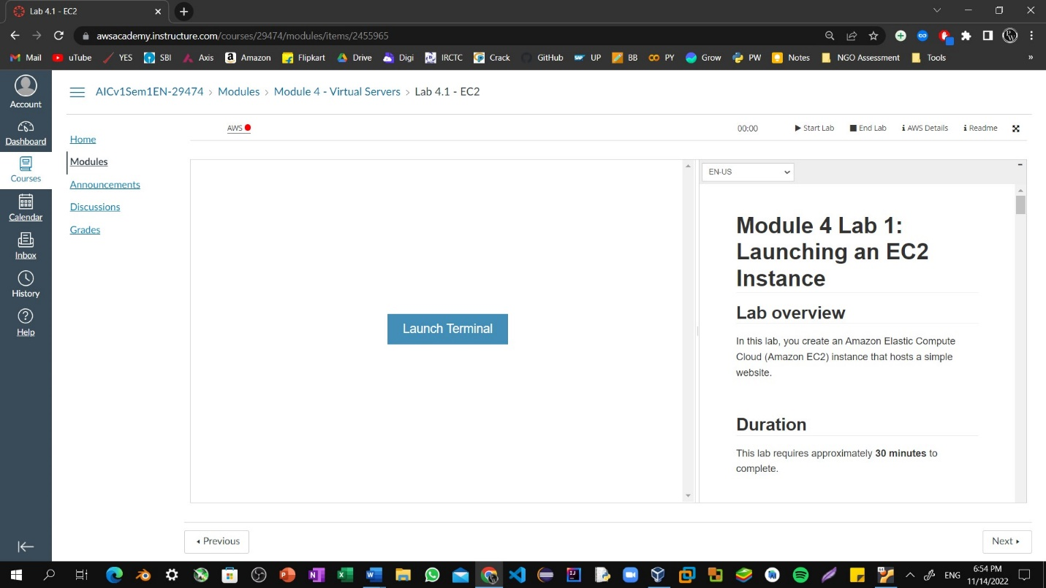

Step2: Choose the **Services** menu, locate the **Compute** services, and select **EC2.**

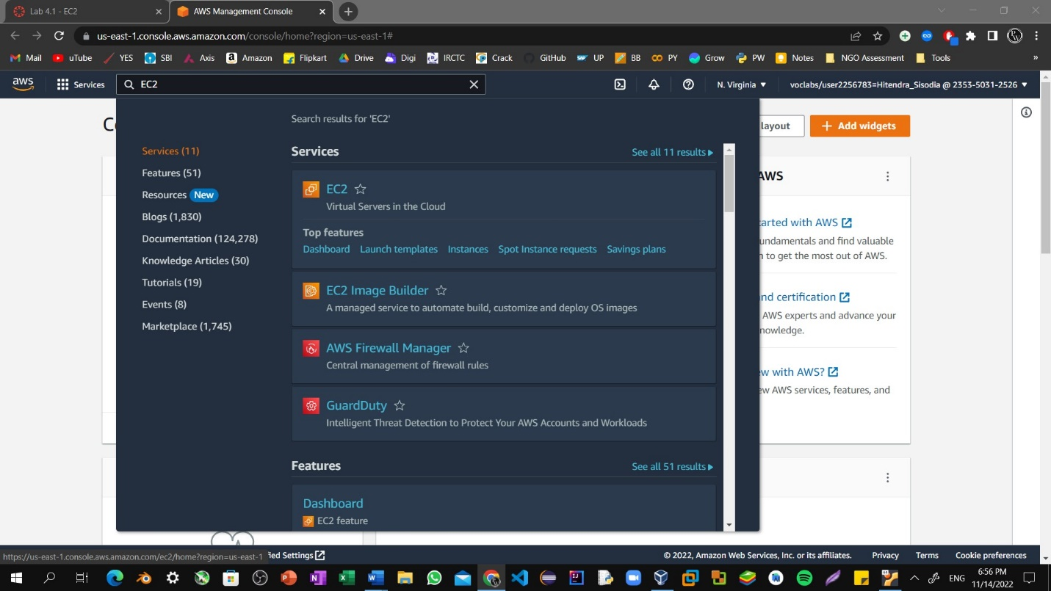

Step3: Choose the **Launch instance** button in the middle of the page, and then select **Launch instance** from the dropdown menu.

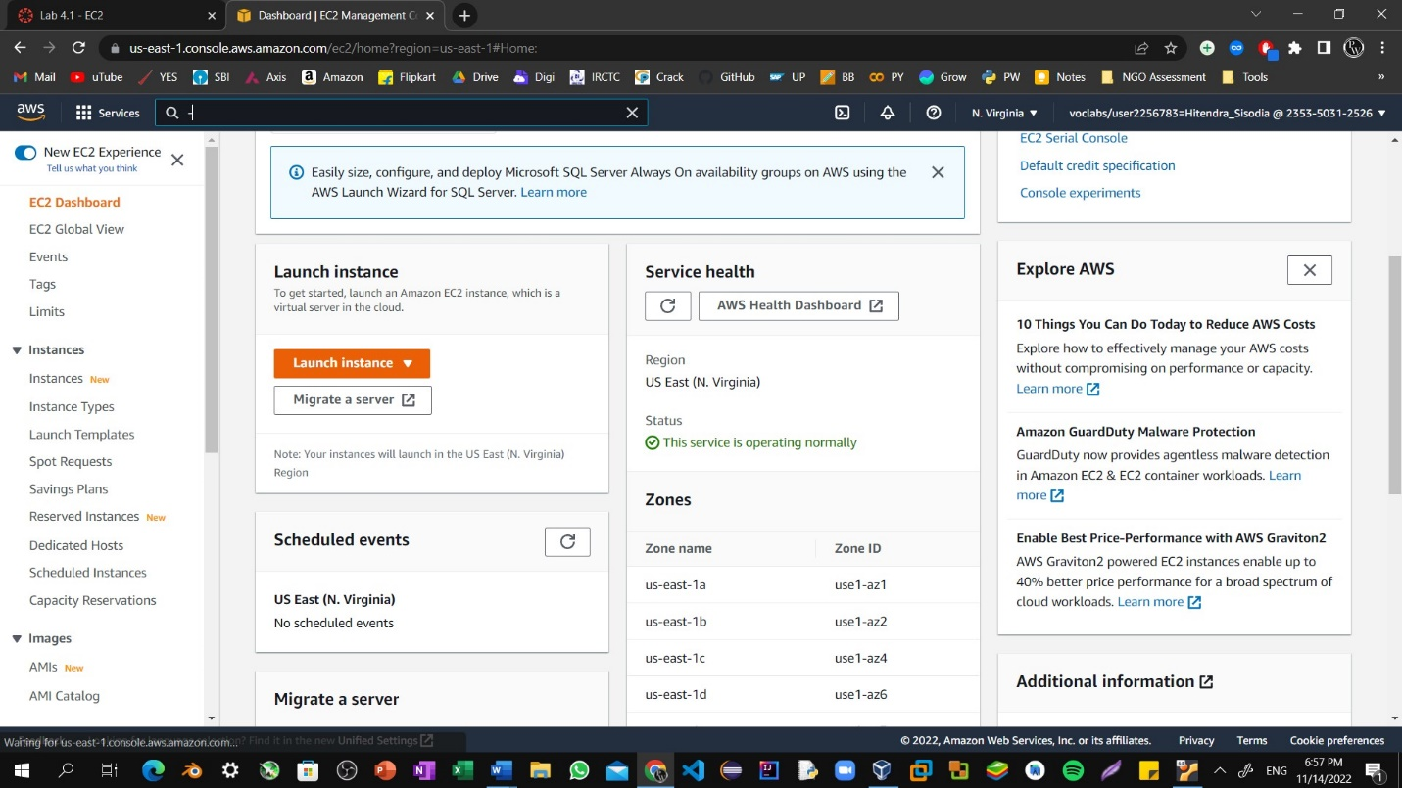

Step4: Name the instance: HitendraSisodia

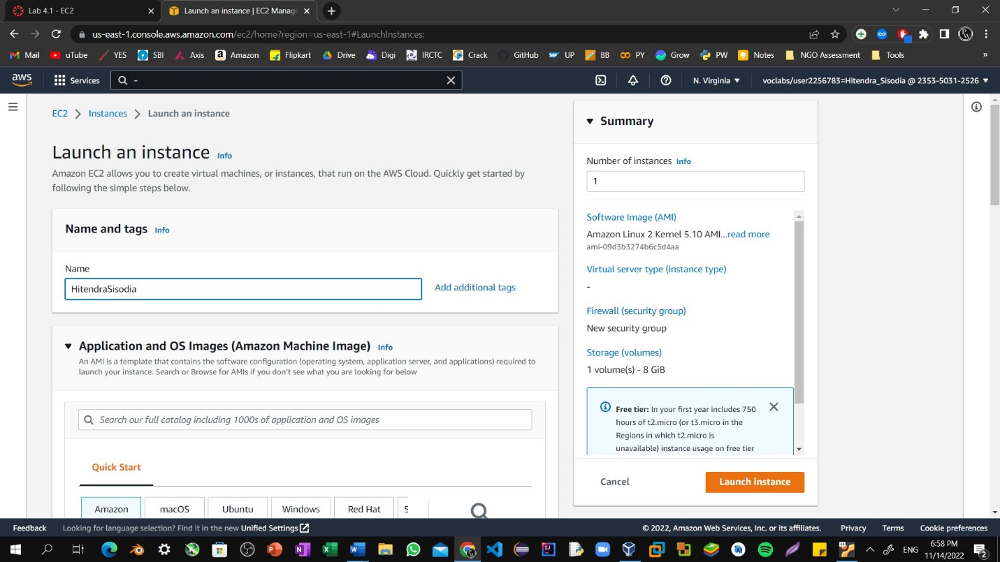

Step5: Choose an AMI from which to create the instance:

In the list of available Quick Start AMIs, keep the default **Amazon Linux** AMI selected.

Also keep the default **Amazon Linux 2 AMI (HVM)** selected.

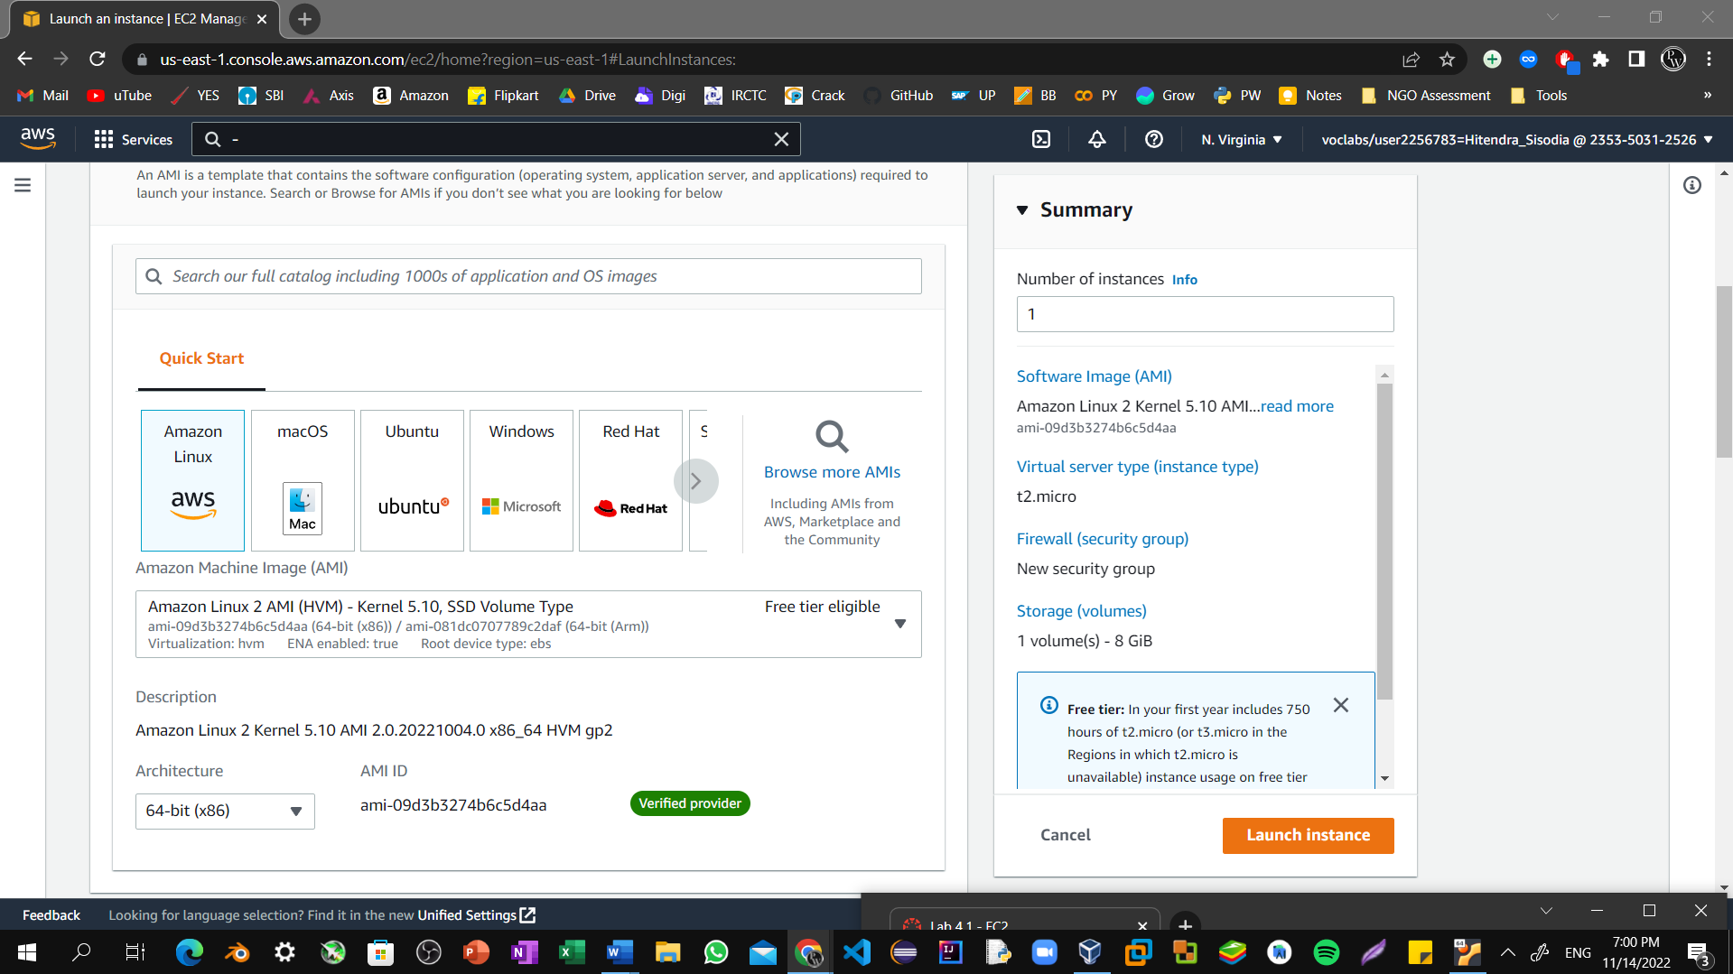

Step6: Specify an Instance type: In the Instance type panel, keep the default **t2.micro** selected.

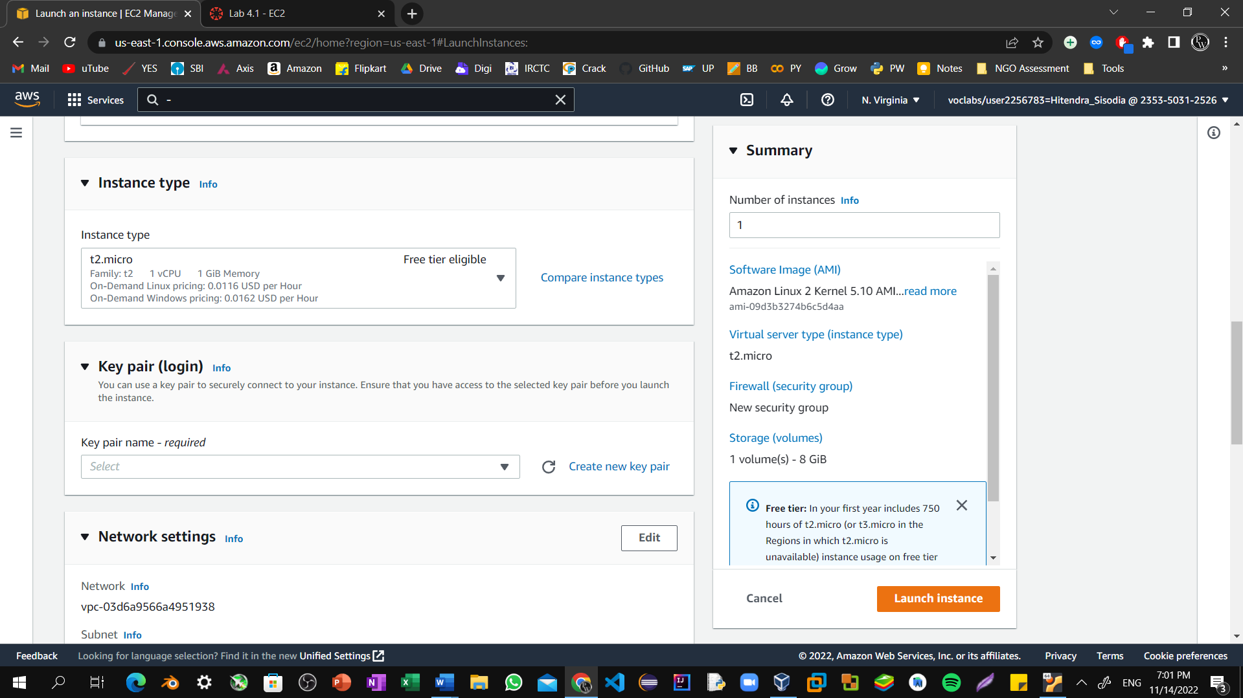

Step7: Select the key pair to associate with the instance. From the **Key pair name** menu, select **vockey**.

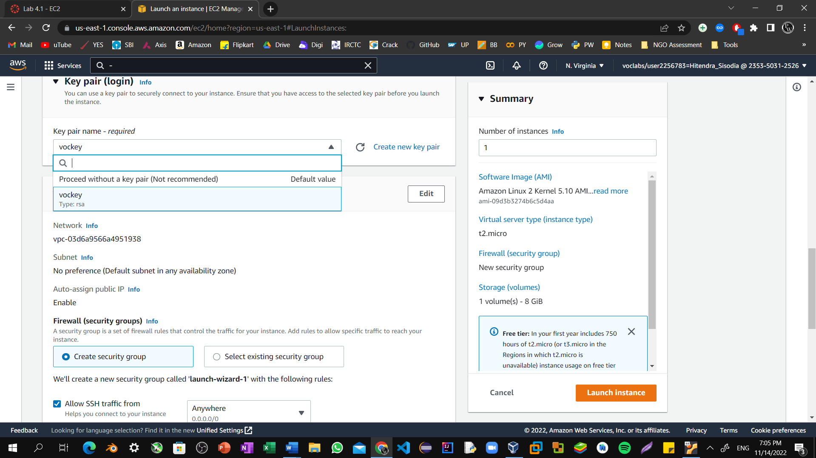

Step8: Next to Network settings, choose **Edit**. Keep the default VPC and subnet settings. Also keep the **Auto-assign public IP** setting set to **Enable**.

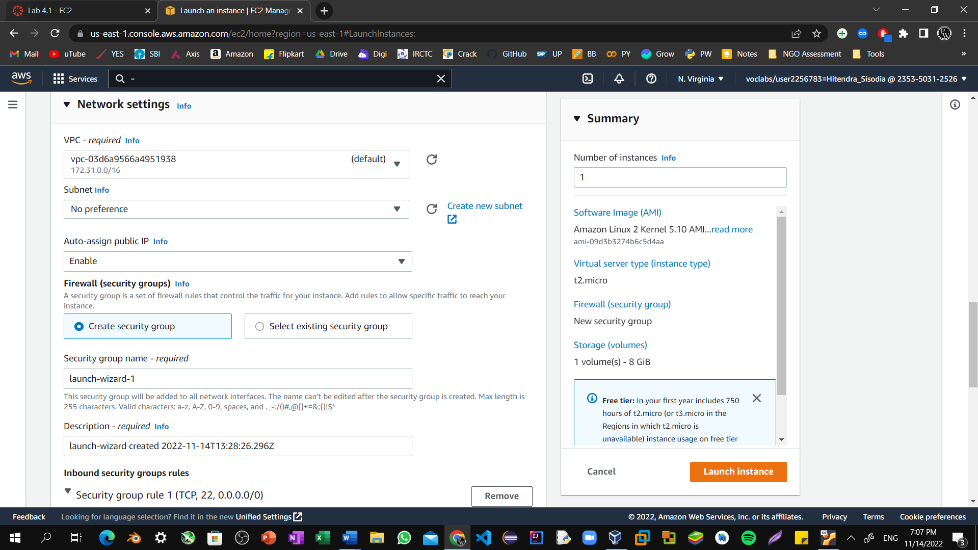

Step9: Under Firewall (security groups), keep the default **Create security group** option chosen.

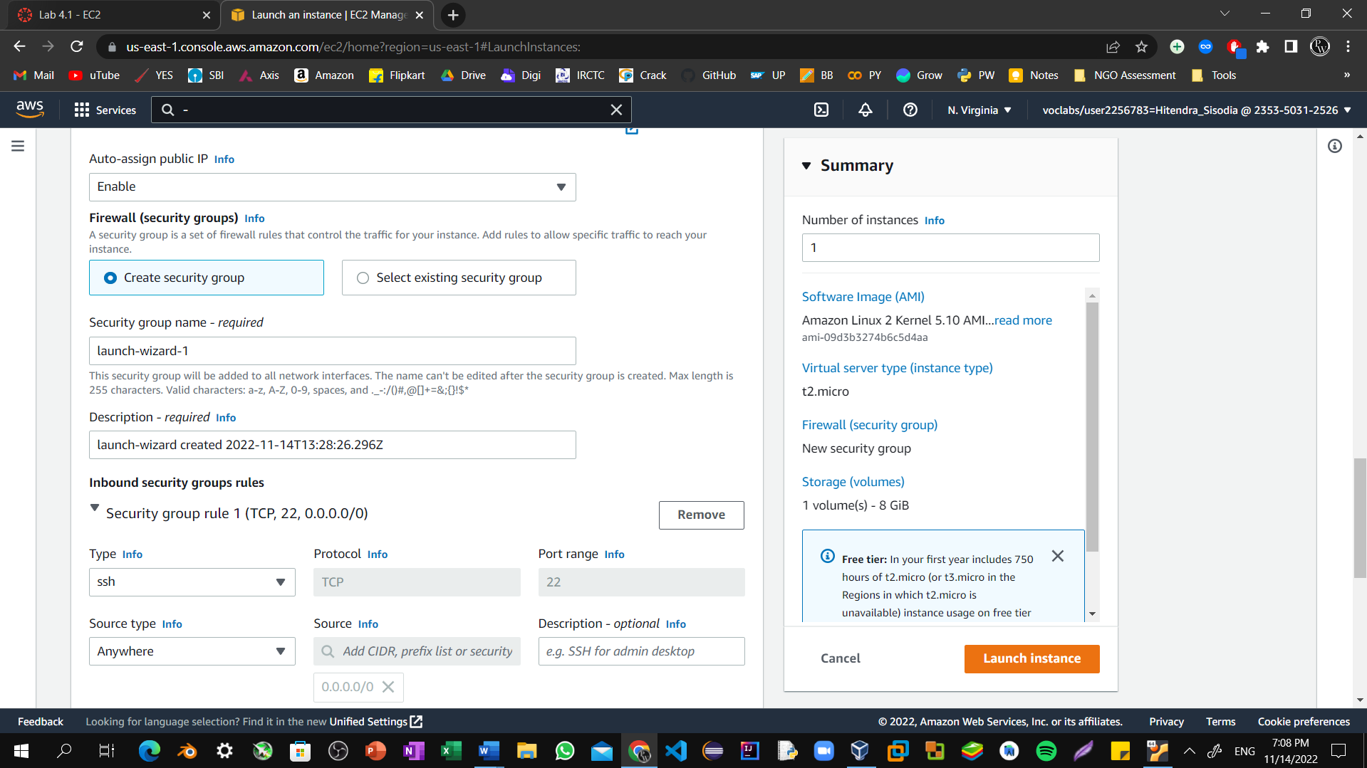

Step10: Configure a new security group:

* Keep the default selection **Create a new security group**.
* **Security group name:** Clear the text and enter Web Server
* **Description:** Clear the text and enter Security group for my web server

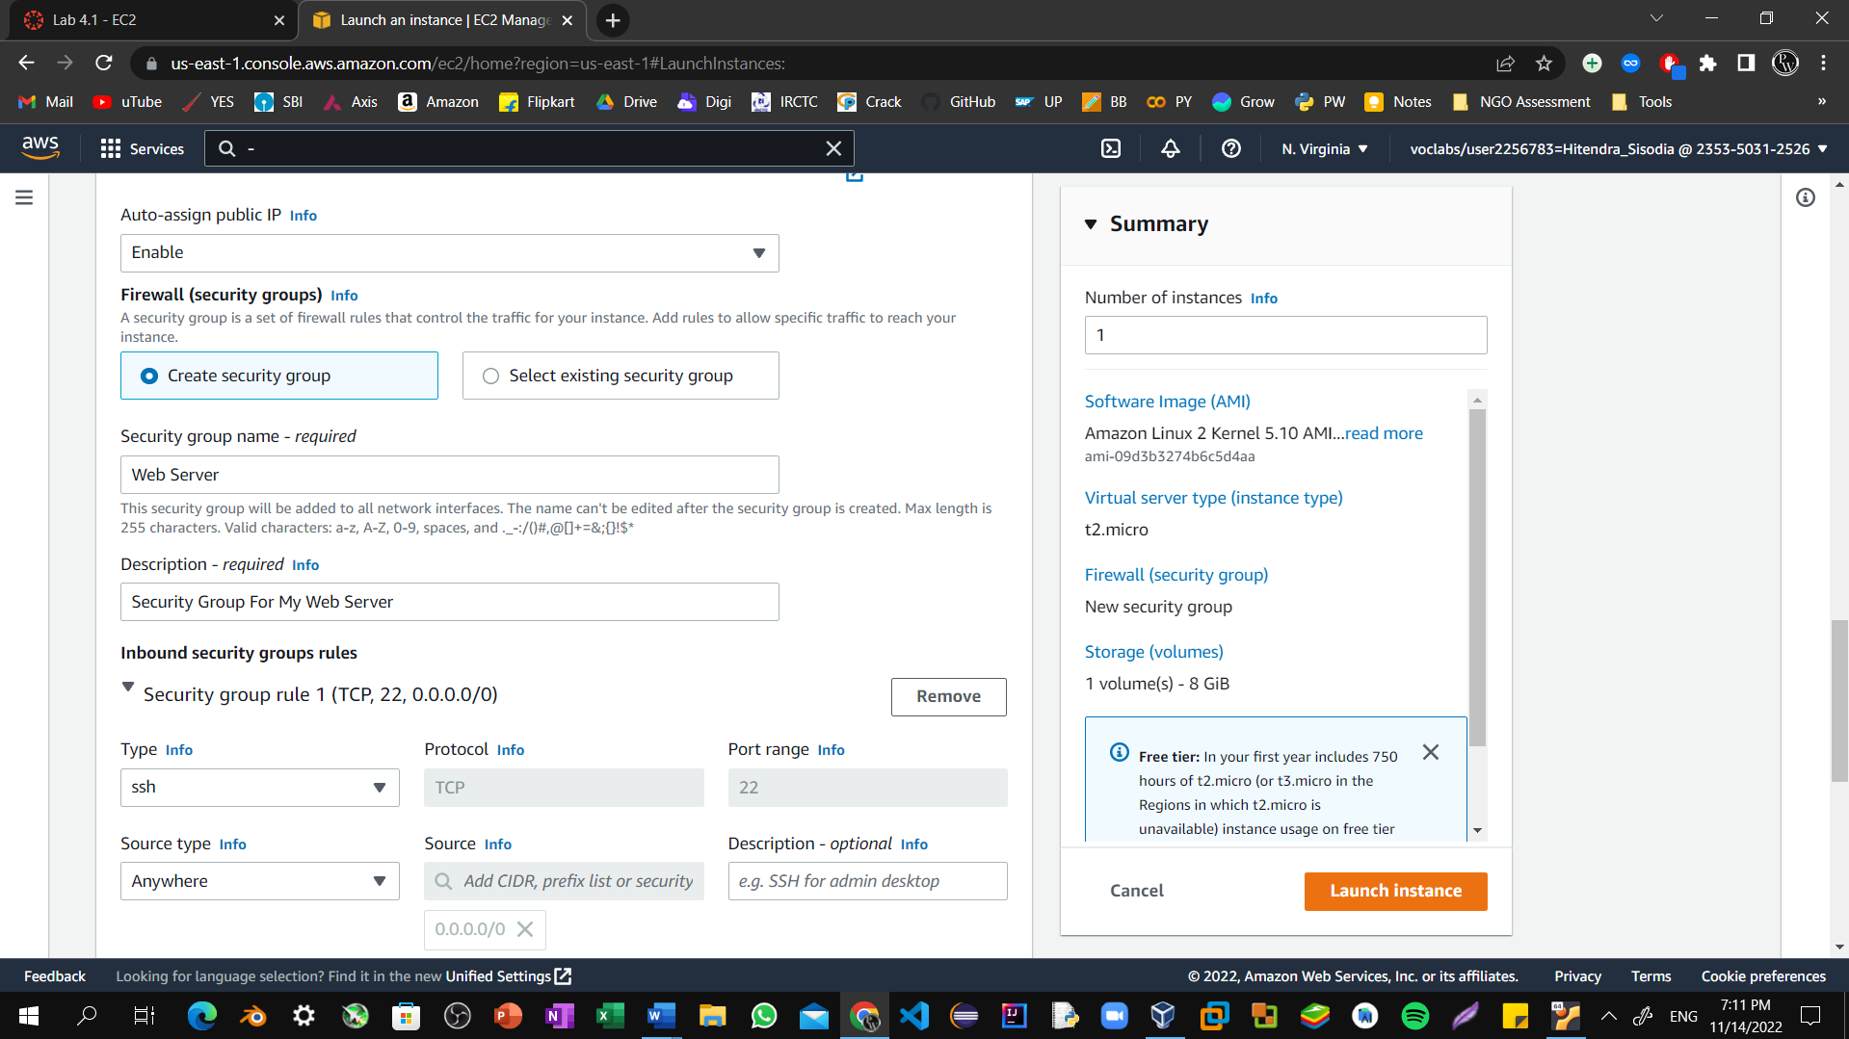

Step11: Choose **Remove** to remove the default SSH inbound rule.

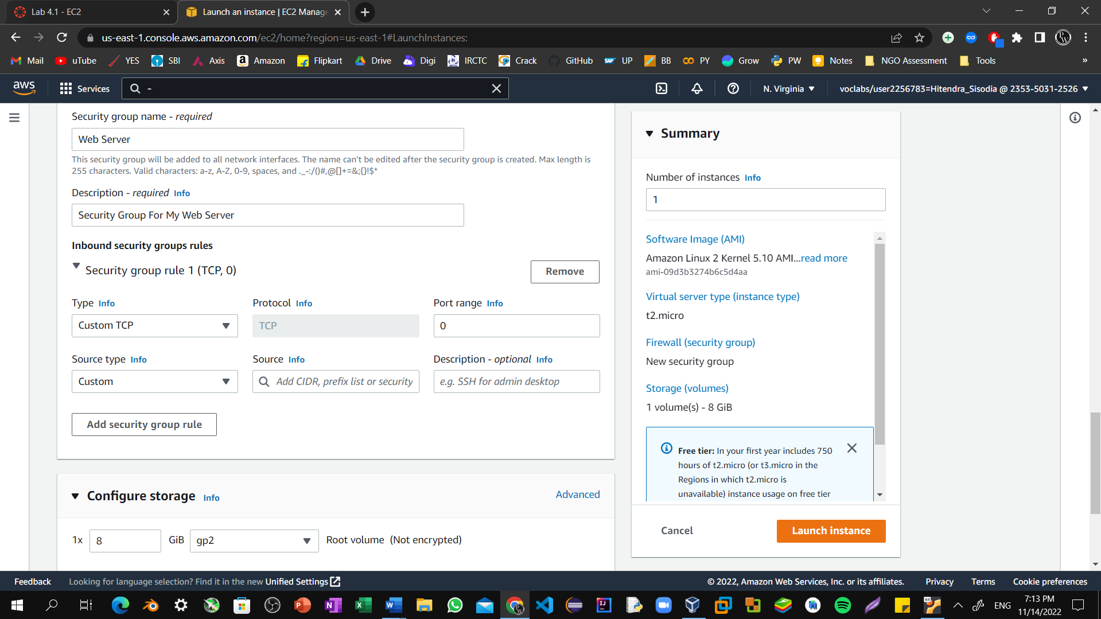

Step12: In the Configure storage section, keep the default settings. You will launch the Amazon EC2 instance using a default Elastic Block Store (EBS) disk volume.

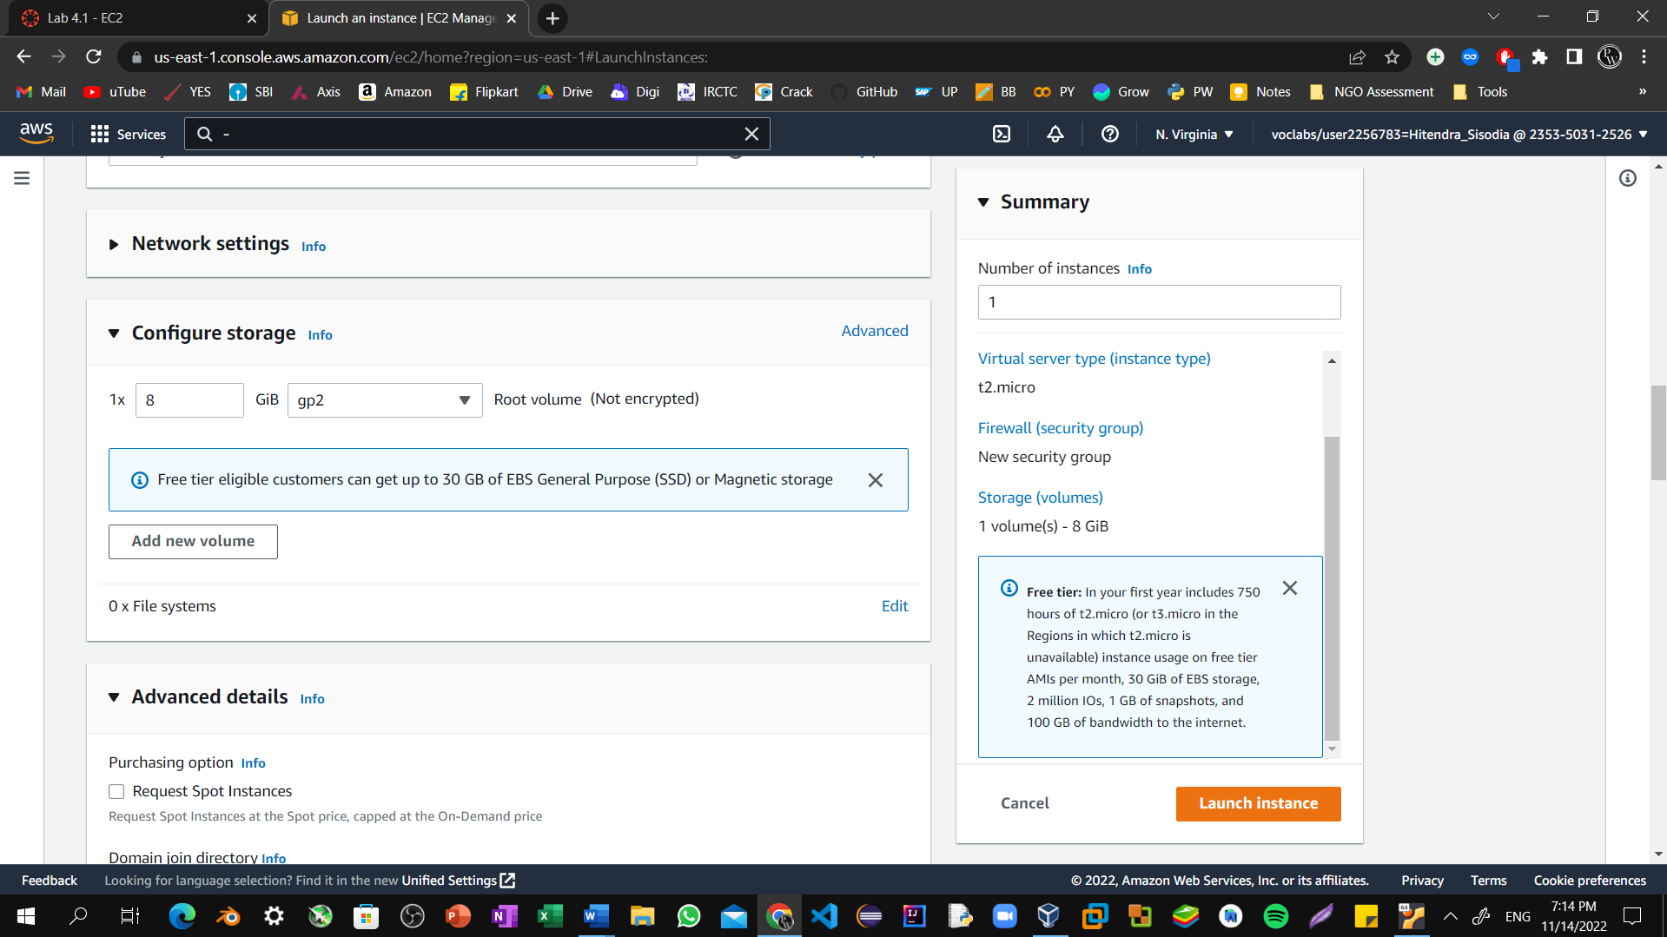

Step13: Configure a script to run on the instance when it launches:

* Expand the **Advanced details** panel.

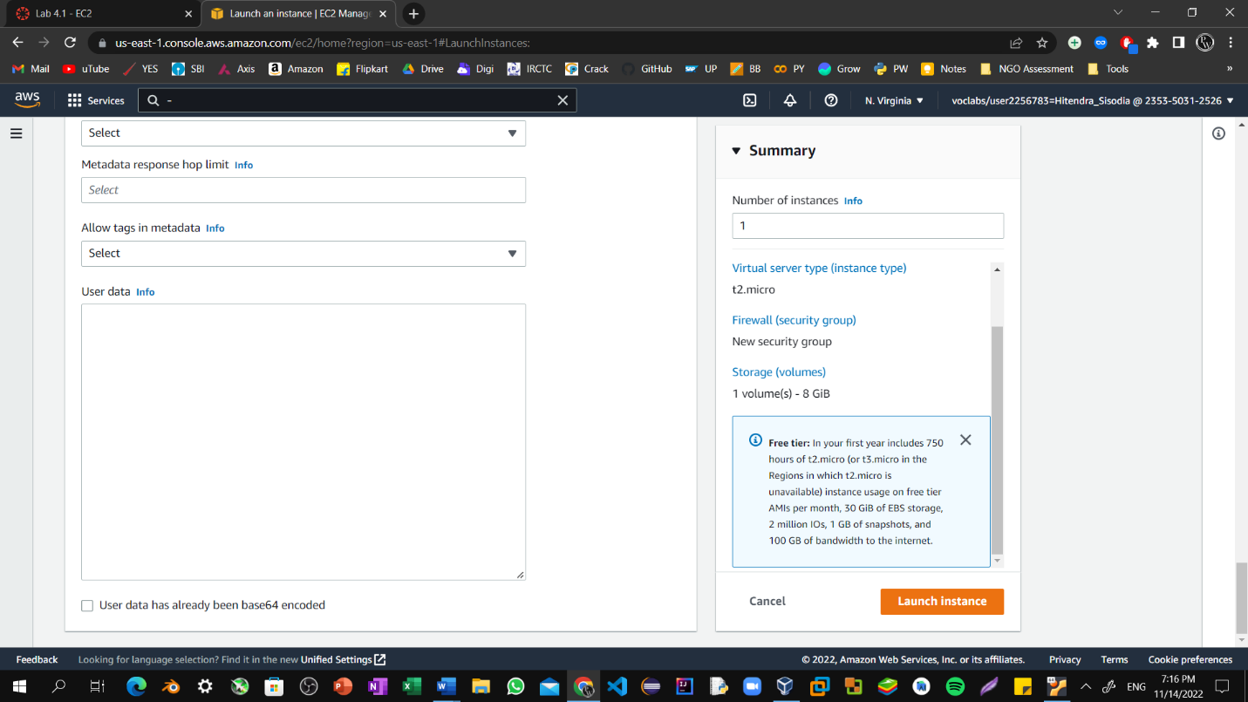

Step14: Scroll to the bottom of the page and then copy and paste the code shown below into the **User data** box.

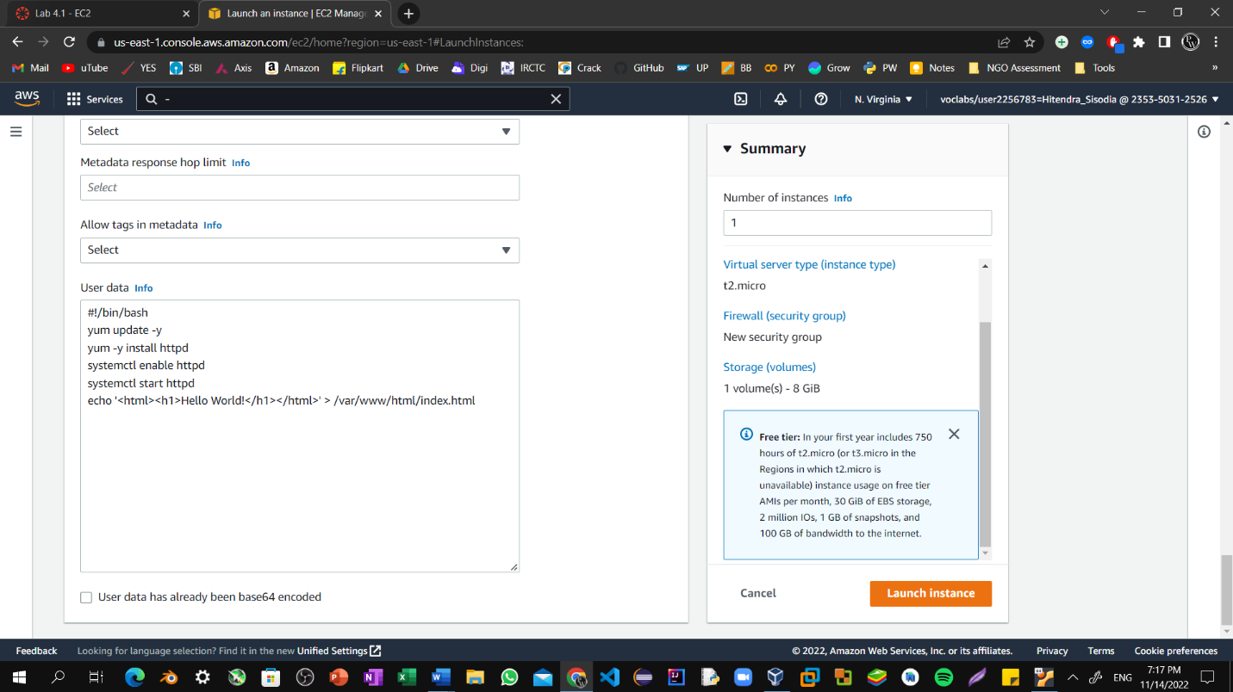

Step15: At the bottom of the **Summary** panel on the right side of the screen choose Launch Instances. You will see a Success message.

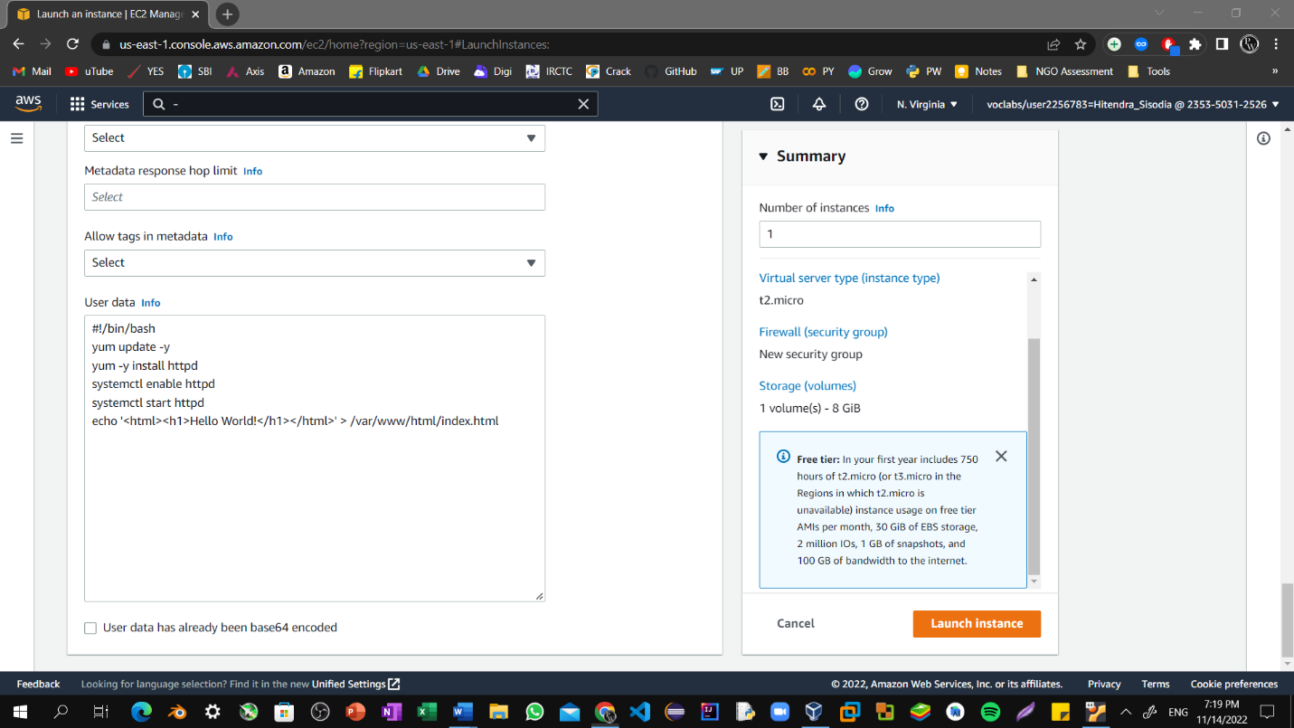

Step16: The instance will first appear in the Pending state, which means it is being launched. The state will then change to Running, which indicates that the instance has started booting. It takes a few minutes for the instance to boot.

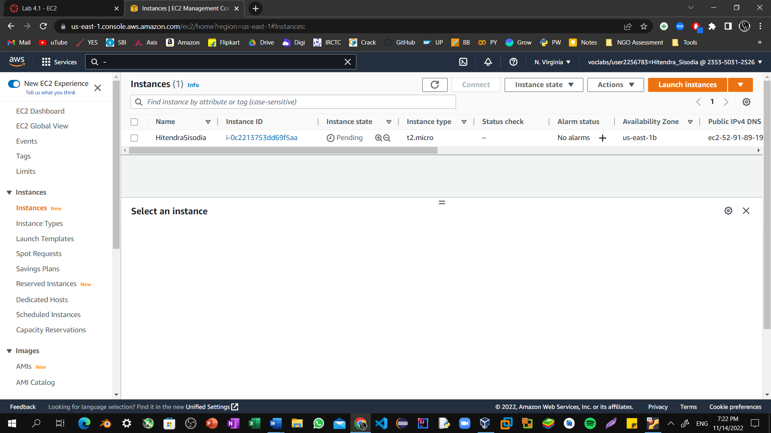

Step17: Before you continue, wait for your instance to display the following:

**Instance state:** Running

**Status check:** 2/2 checks passed

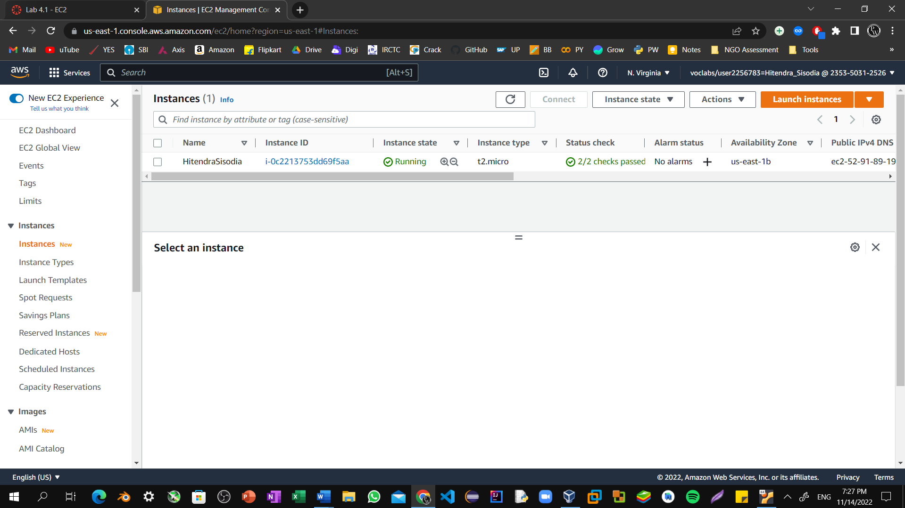

Step18: From the **Details** tab, copy the **Public IPv4 address** value of your instance to your clipboard.

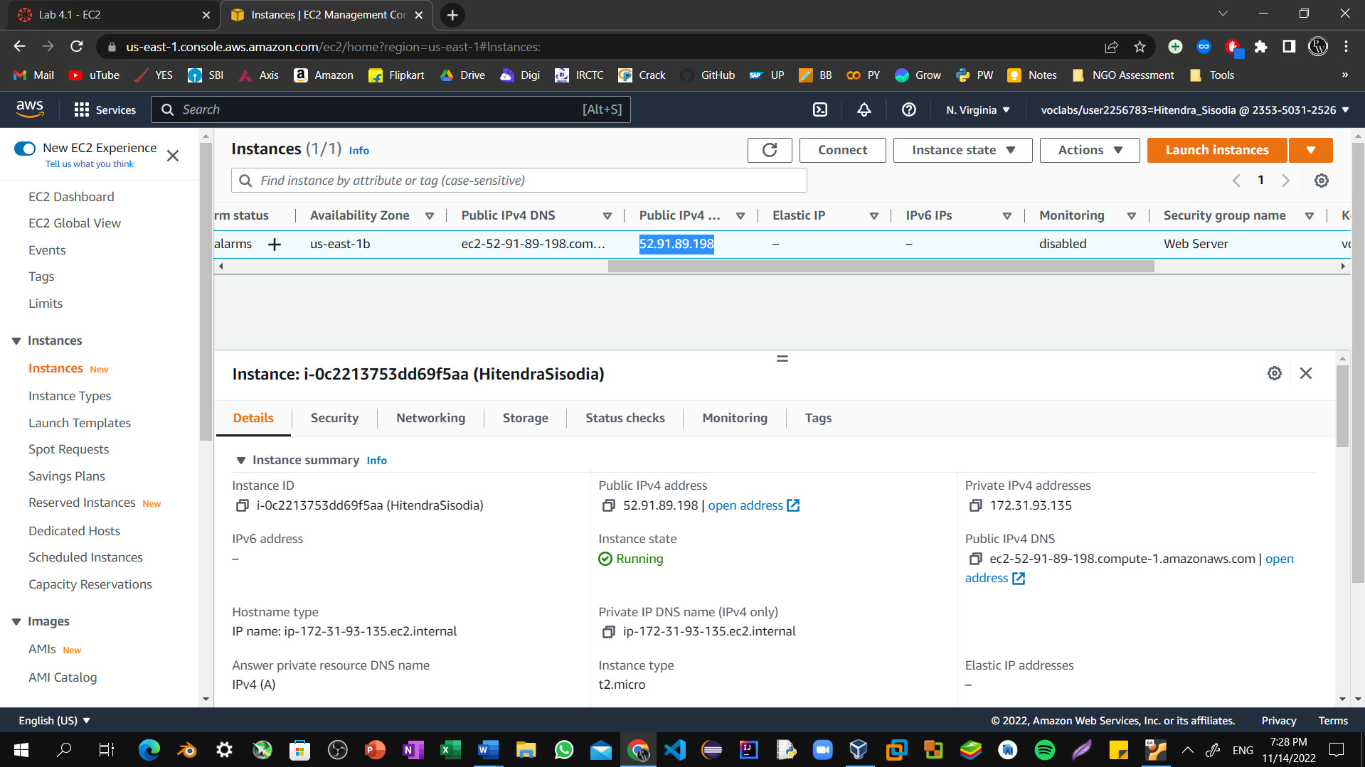

Step19: Open a new tab in your web browser, paste the public IP address you just copied, and press **Enter**.

The webpage does not load. You must update the security group to be able to access the page.

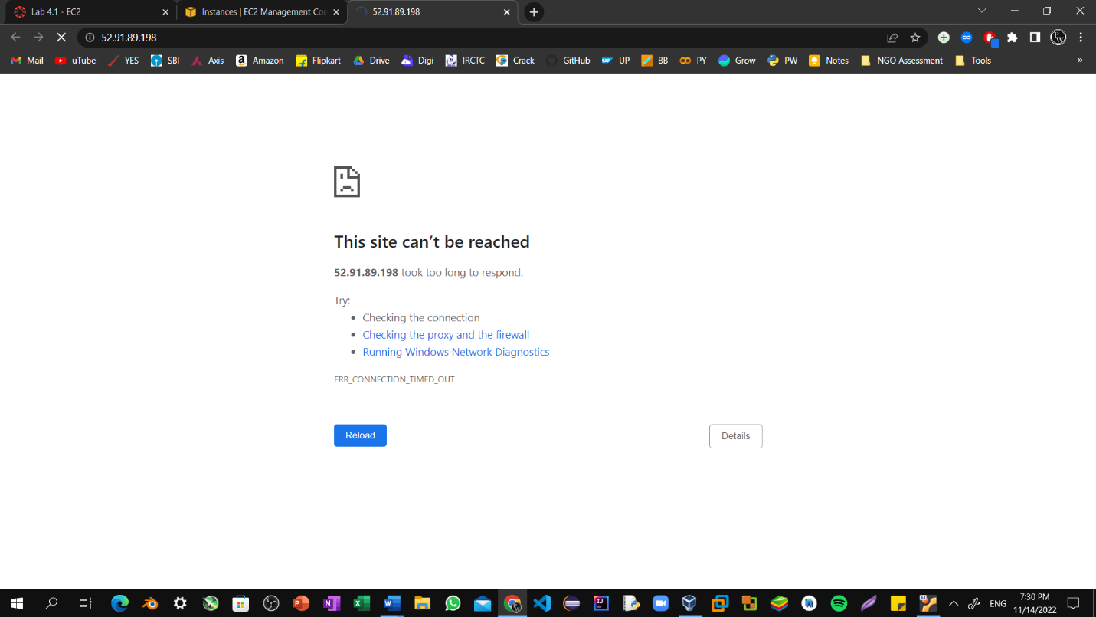

Step20: Return to the **EC2 Management Console** browser tab.

In the left navigation pane, under **Network & Security**, choose **Security Groups**.

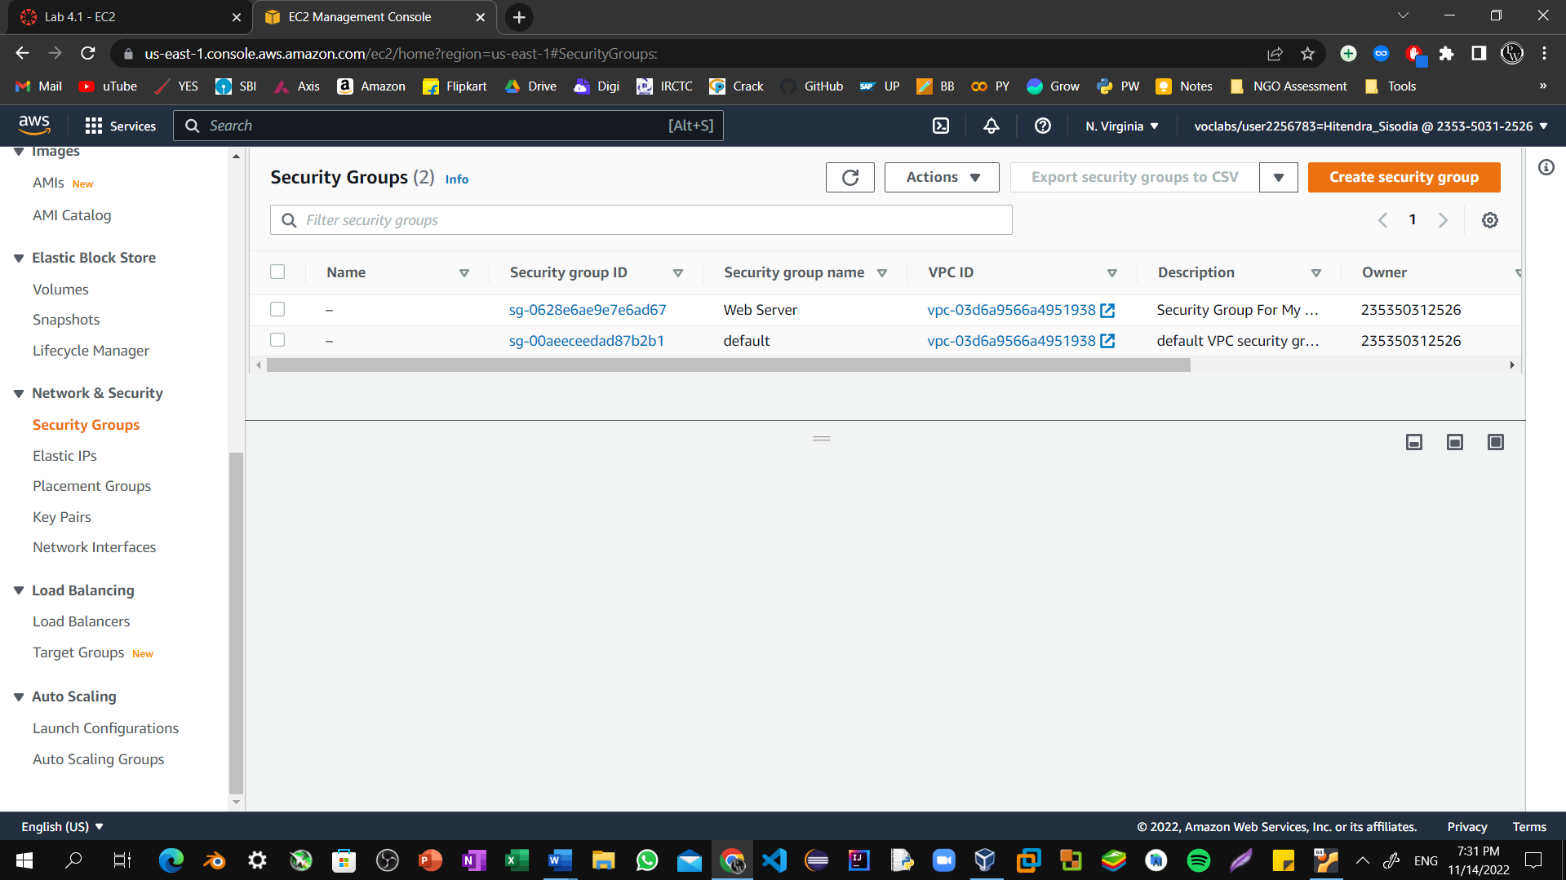

Step21: Select the **Web Server** security group, which you created when launching your EC2 instance. In the lower pane, choose the **Inbound rules** tab.

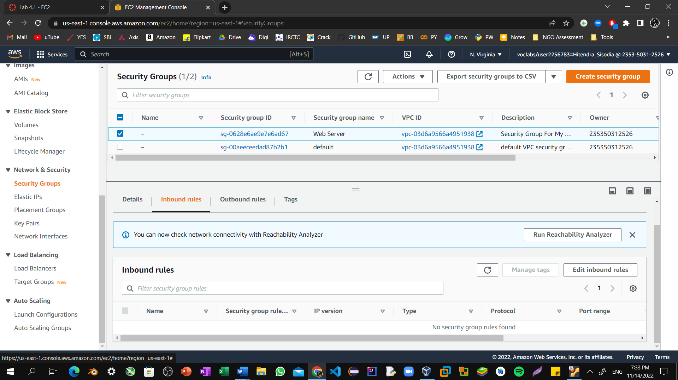

Step22: Choose **Edit inbound rules**, and then choose **Add rule**.

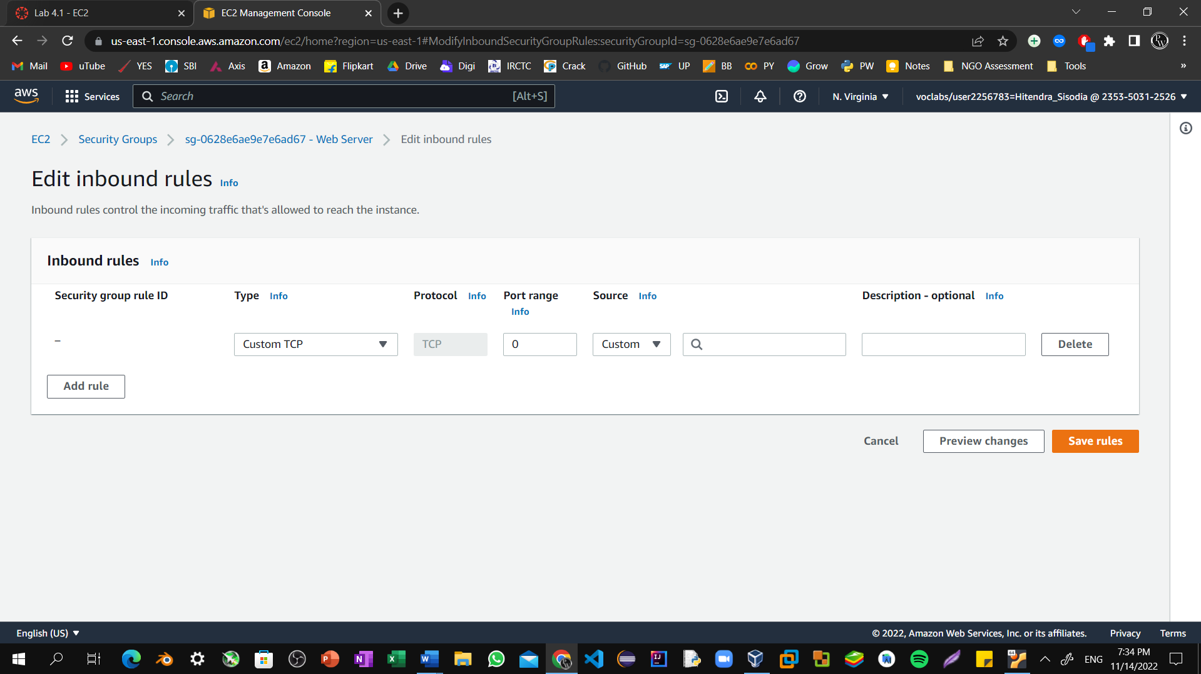

Step23: Configure the following:

**Type:** HTTP

**Source:** Anywhere-IPv4 Choose **Save rules**

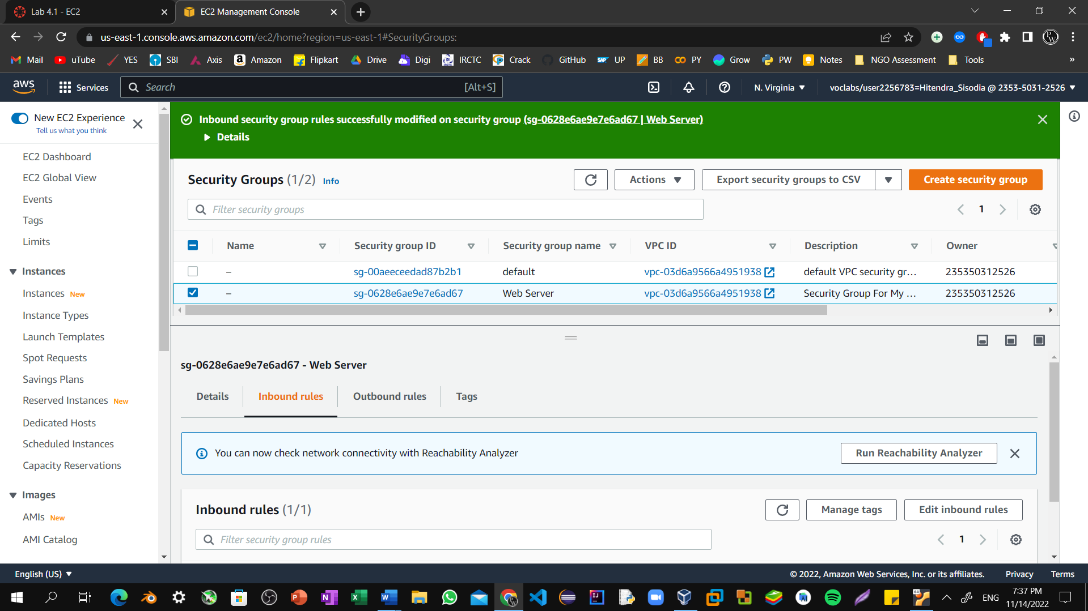

Step24: Return to the tab that you used to try to connect to the web server. The page should display the message Hitendra Sisodia.

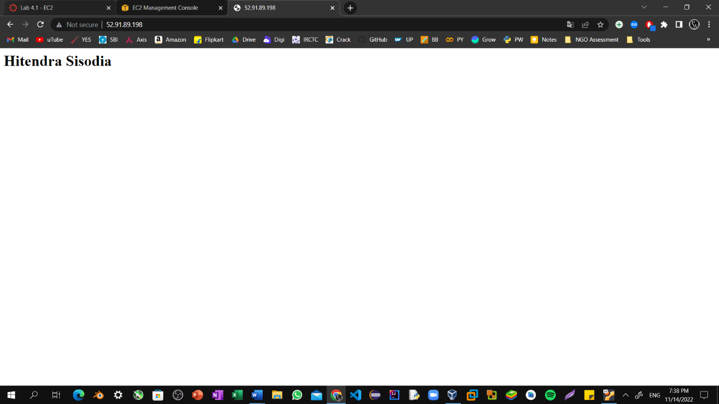

Step25: Return to the **EC2 Management Console** browser tab.

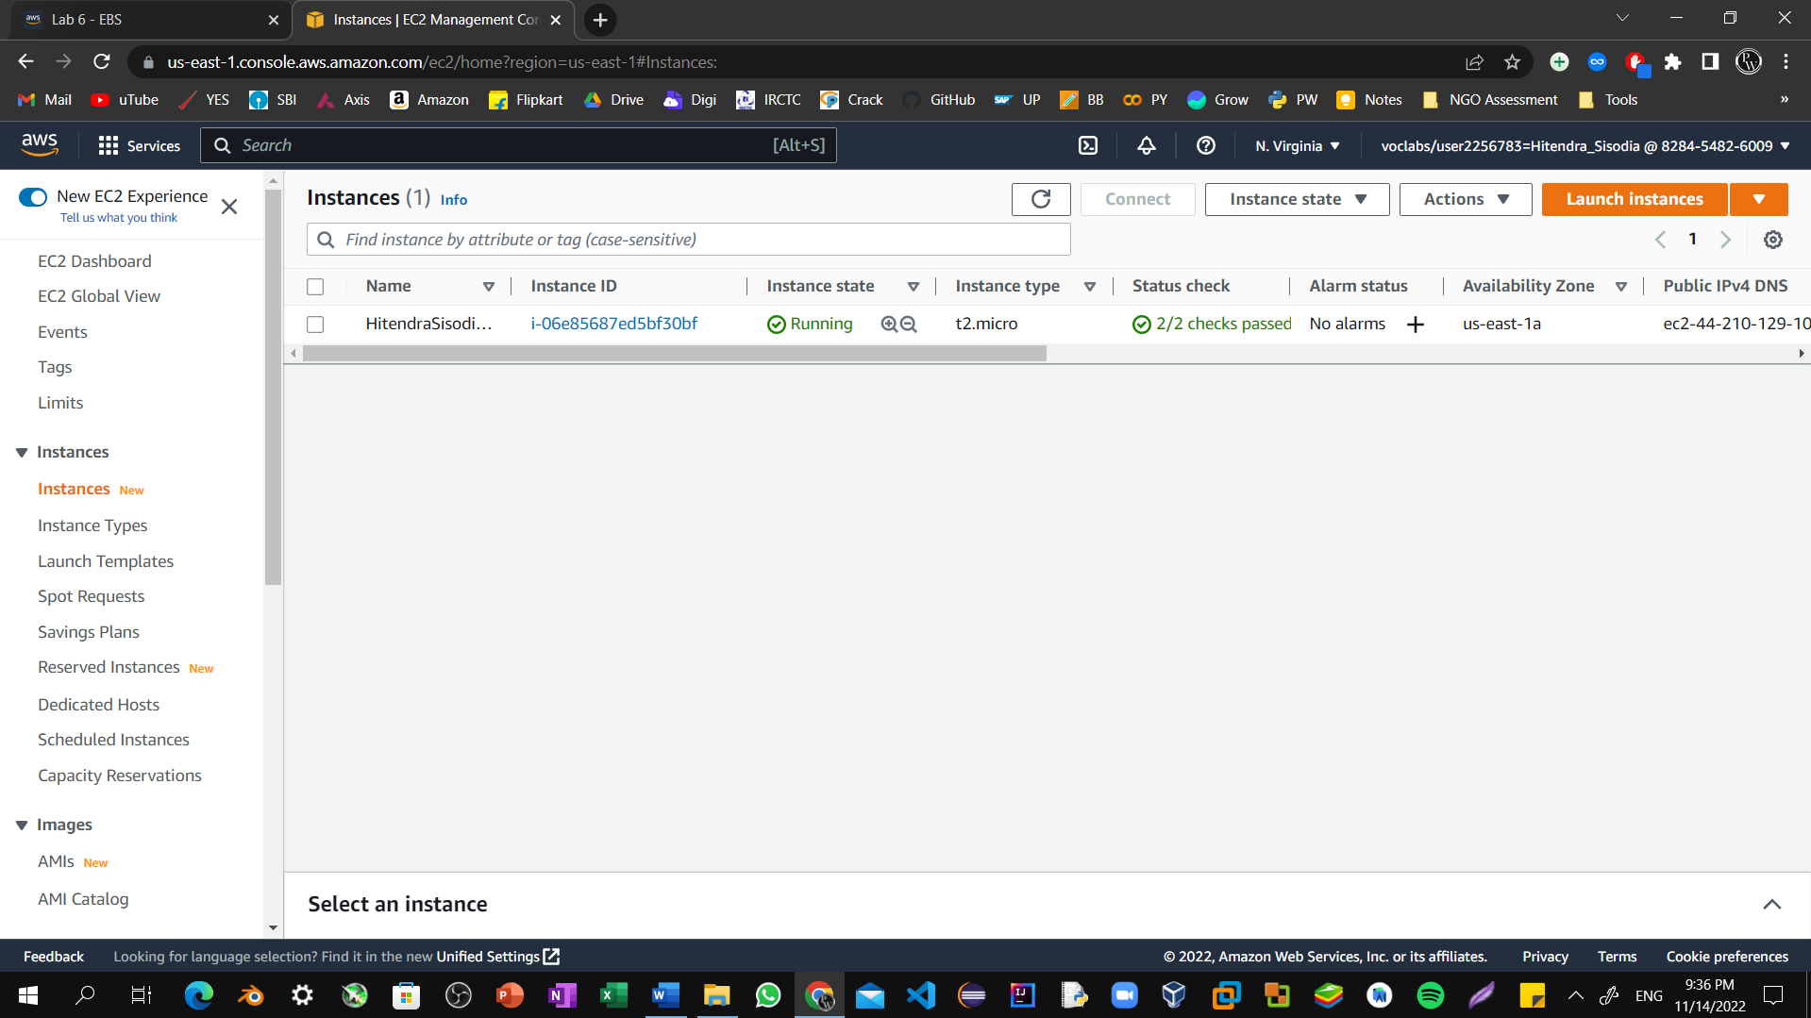

Step26: In the left navigation pane, under **Instances**, choose **Instances**. Select the **Web Server** instance, and in the **Networking** tab below, note the **Availability Zone** in which your instance is running.

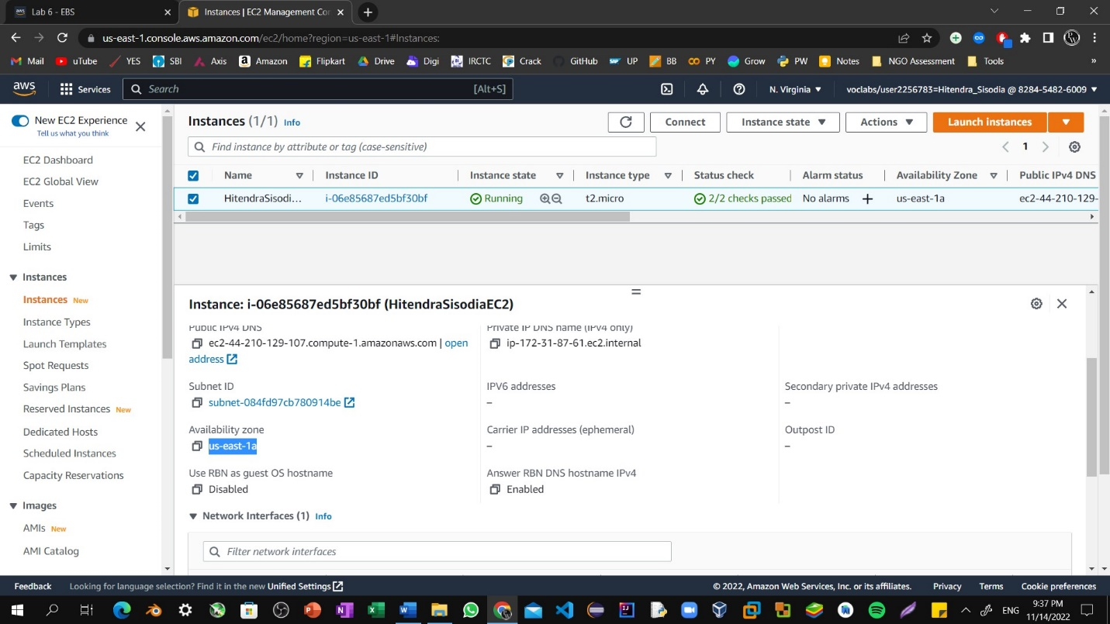

Step27: In the left navigation pane, under **Elastic Block Store**, select **Volumes**.

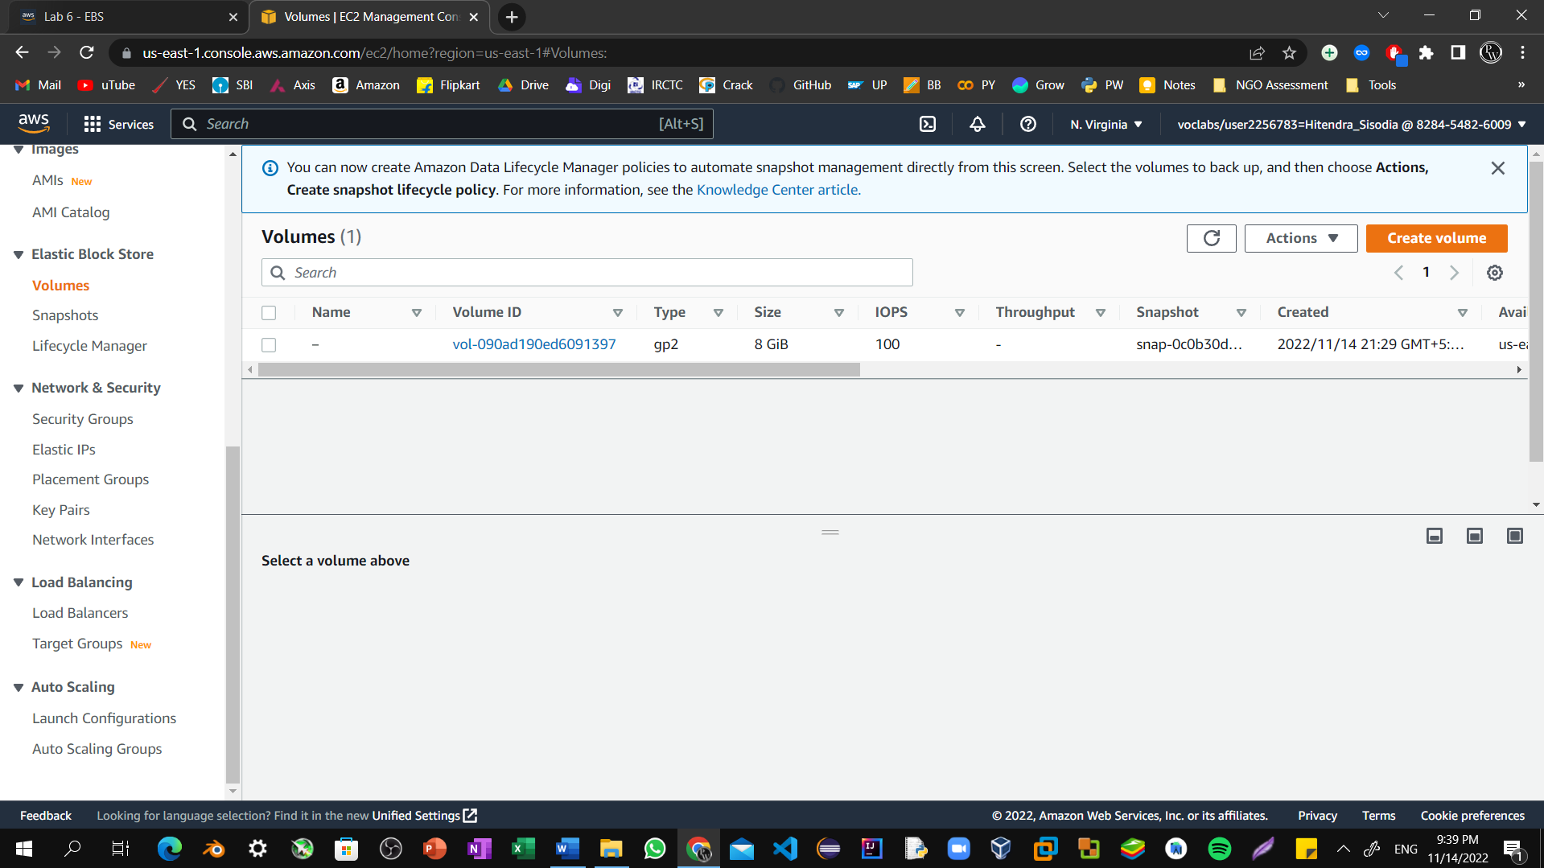

Step28: Select **Create volume**.

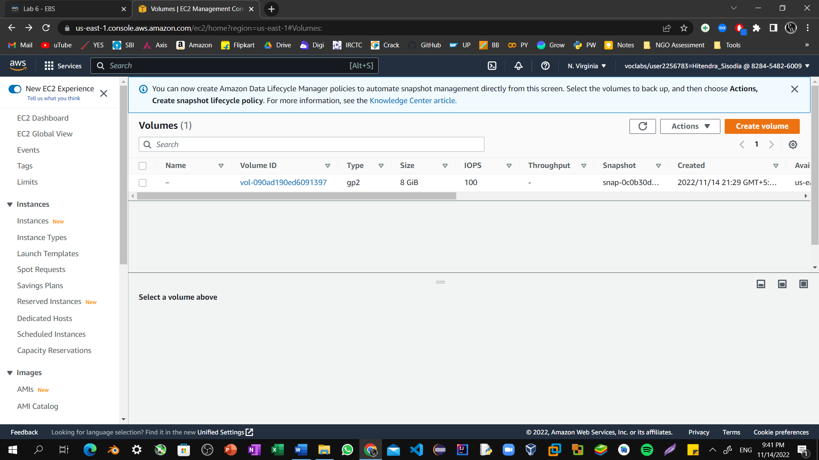

Step29: For **Size**, enter 1 to create a volume with 1 GiB. For **Availability Zone**, select the same Availability Zone that your EC2 instance is running in.

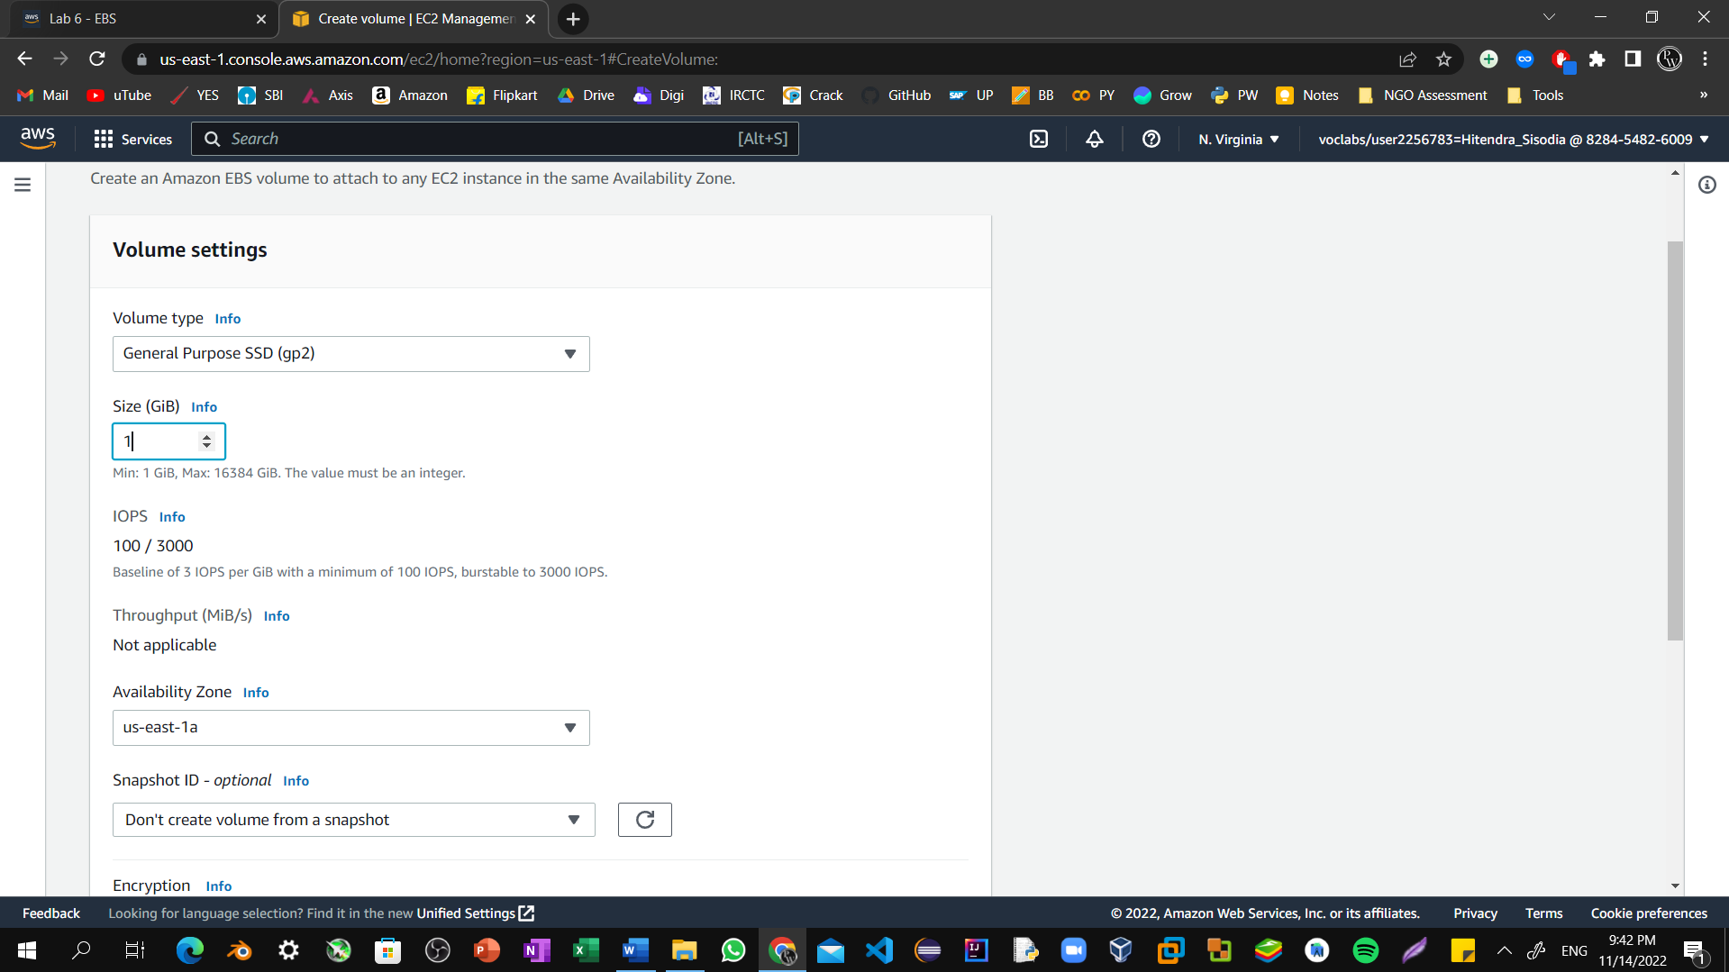

Step30: Scroll down and select **Create volume**.

The new volume appears in the volumes list with a state of available.

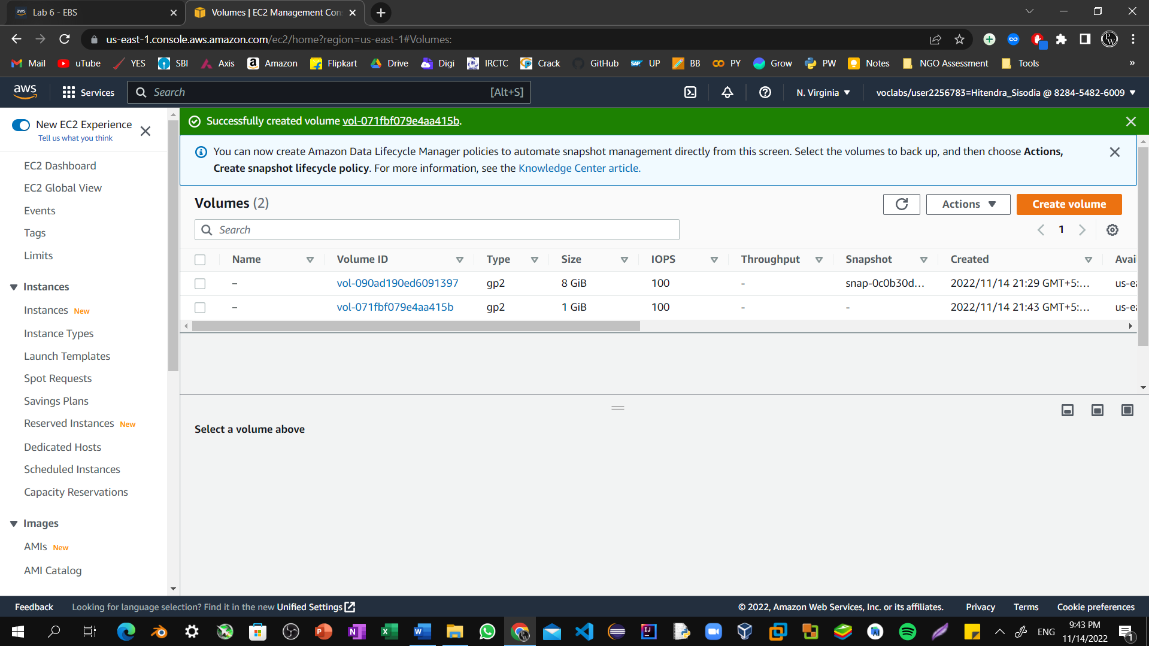

Step31: Select the new 1 GiB size volume. Then, choose **Actions**, and Select **Attach volume**.

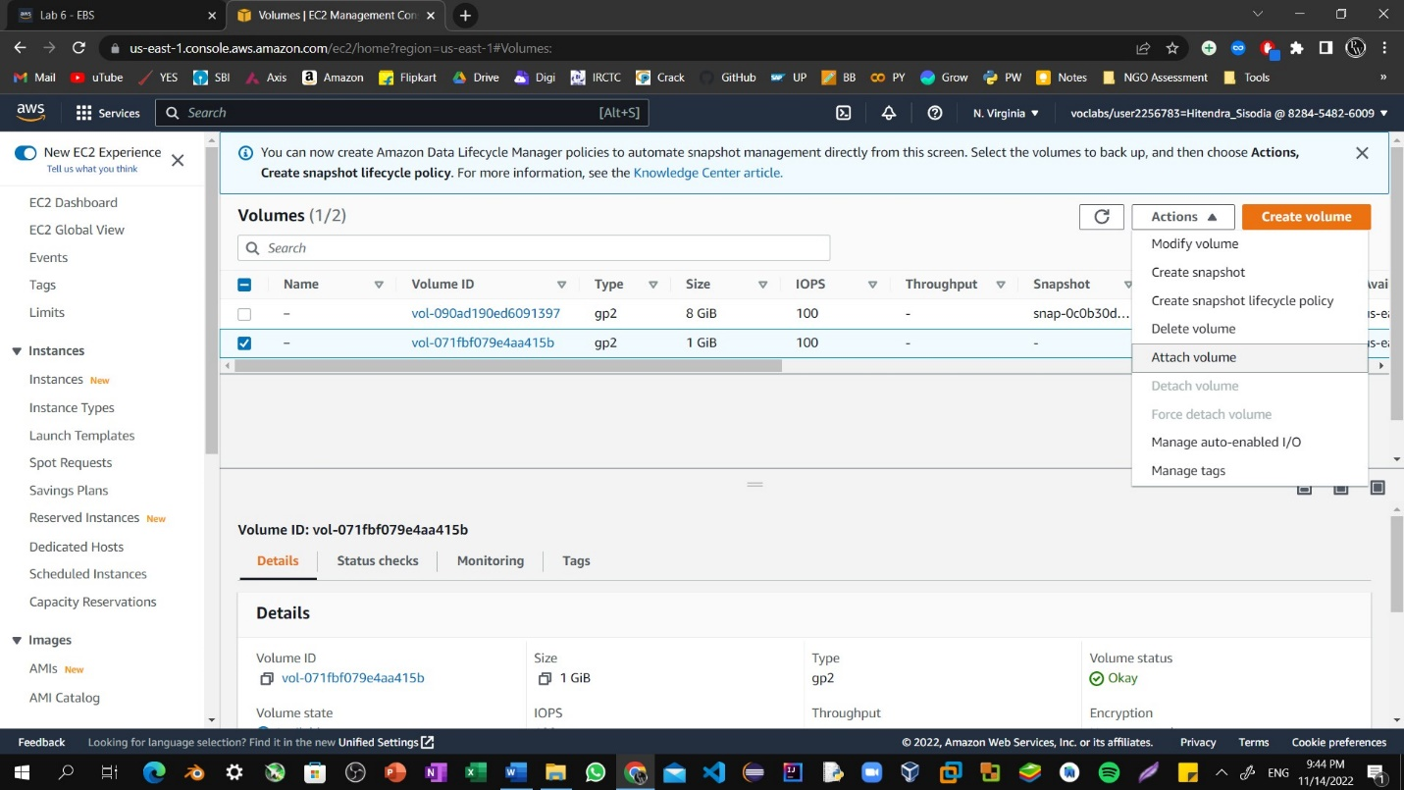

Step32: Select the **Instance** drop-down menu, and then select your EC2 instance. The list of instances will automatically populate.

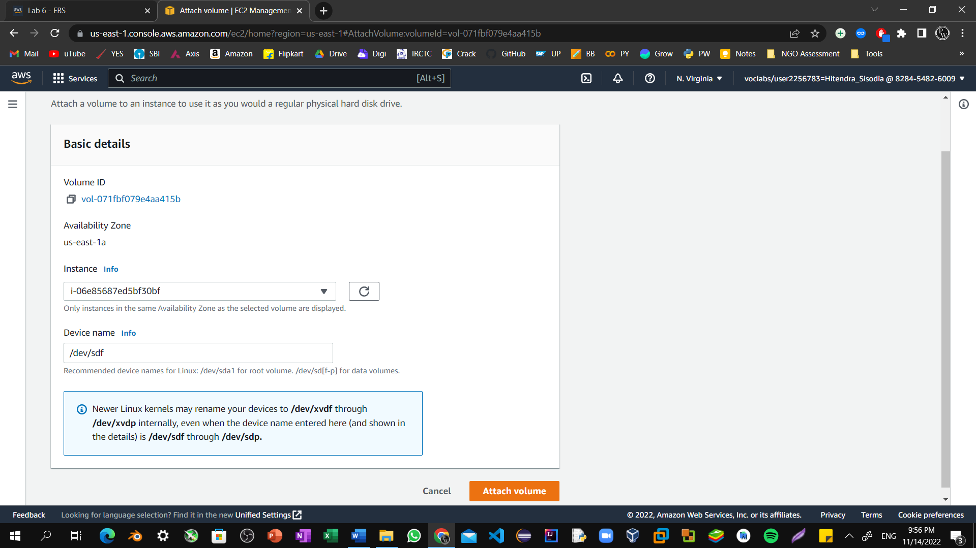

Step33: Select **Attach volume**.

The state of the volume changes to in-use. The new volume is now attached to your EC2 instance. Refresh The webpage that we created using EC2 instance now updated with EBS Storage.

